Example N0 1:

Input:
using System;

namespace CONSOLEAPP07
{
class Program
{
static void Main(string[] args)
{
string firstName = "Abdullah";
string fatherName = "Muhammad Sadiq";
string emailId = "abdullahsadiq0701@gmail.com";
string contactNumber = "0312-1231231";
Console.WriteLine("-My Profile");
Console.Write("My name is: "+firstName+"\n"+"My Father name is: "+fatherName+"\n"+"MY Email ID: "+emailId+"\n"+"My Contact Number: "+contactNumber);
}
}
}
Output:
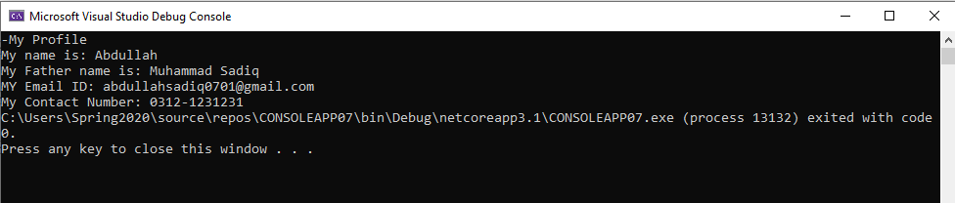Example No 2:
Input:
using System;

namespace CONSOLEAPP07
{
class Program
{
static void Main(string[] args)
{
Console.WriteLine("Enter your Name");
string firstName = Console.ReadLine();
Console.WriteLine("Enter Your Father Name");
string fatherName = Console.ReadLine();
Console.WriteLine("Enter Your Gmail");
string emailId = Console.ReadLine();
Console.WriteLine("Enter Your Contact Number");
string contactNumber = Console.ReadLine();
Console.WriteLine("-My Profile");
Console.Write("My name is: "+firstName+"\n"+"My Father name is: "+fatherName+"\n"+"MY Email ID: "+emailId+"\n"+"My Contact Number: "+contactNumber);
}
}
}

Output:
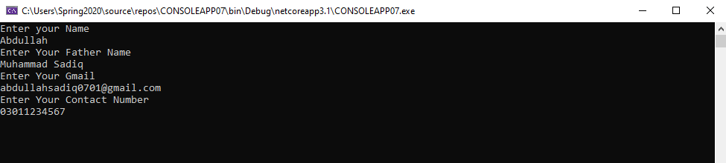
Example No 3:
Input:
using System;

namespace CONSOLEAPP07
{
class Program
{
static void Main(string[] args)
{
int numA = 10;
int numB = 20;
int result;
result = numA + numB;
Console.WriteLine("the sum is" + result);
result = numA - numB;
Console.WriteLine("The sub is" + result);
result = numA * numB;
Console.WriteLine("The sum is" + result);
}
}
}

Output:
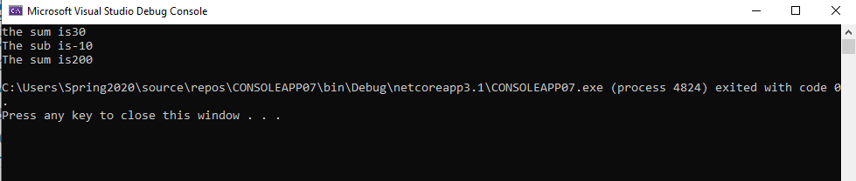

Example No 4:
Input:
using System;

namespace CONSOLEAPP07
{
class Program
{
static void Main(string[] args)
{
Console.WriteLine("Enter Number From 0-9");
string numAuser = Console.ReadLine();
int numA = Convert.ToInt32(numAuser);
string numBuser = Console.ReadLine();
int numB = Convert.ToInt32(numBuser);
int result;
result = numA + numB;
Console.WriteLine("the sum is" + result);
result = numA - numB;
Console.WriteLine("The sub is" + result);
result = numA * numB;
Console.WriteLine("The sum is" + result);
}
}
}

Output:
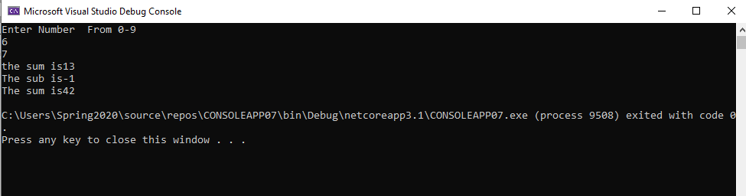

Task No 2: Write a program to display your personal information.

Input:
using System;

namespace My_Profile
{
class Program
{
static void Main(string[] args)
{
string Name = "Abdullah";
string fatherName = "Muhammad sadiq";
string Age = "17";
string Address = "Karachi, Pakistan";
string universityName = "Bahria University Karachi Campus";
string nicNumber = "42401-0000000-0";
string phoneNumber = "0301-0000000";
Console.WriteLine("-My Profile-");
Console.Write("My name is; " + Name + "\n" + "My Father name is :" + fatherName + "\n" + "My age is: " + Age + "\n" + "I live in " + Address + "\n" + "I am a student of " + universityName + "\n" + "My NIC Number is :" + nicNumber + "\n" + "My Mobile Phone Number is :" + phoneNumber);
}
}
}

Output:
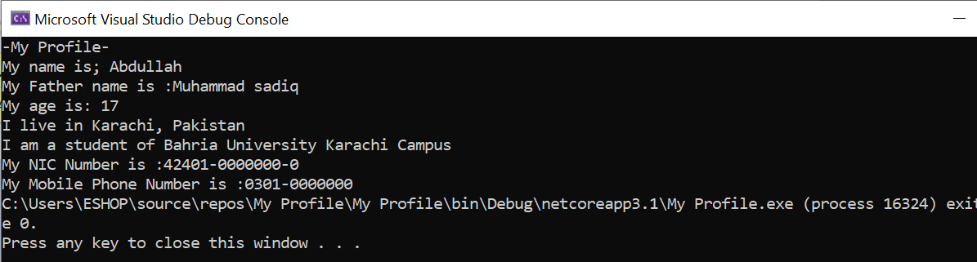
Task No 3: Write a program to display Your inter/ matric marks sheet.
Input:
using System;

namespace My_Marksheet
{
class Program
{
static void Main(string[] args)
{
string physicsMarks = "93/100";
string chemistrymarks = "96/100";
string mathsMarks = "95/100";
string englishMarks = "95/100";
string urduMarks = "94/100";
string IslamiatMarks = "48/50";
Console.WriteLine("\t-Marks Sheet-");
Console.WriteLine("Subject \t Marks");
Console.Write("-Physics \t:" + physicsMarks + "\n" + "-Chemistry \t:" + chemistrymarks + "\n" + "-Maths \t:" + mathsMarks + "\n" + "-English \t:" + englishMarks + "\n" + "-Urdu \t:" + urduMarks + "\n" + "-Islamiat \t:" + IslamiatMarks);
}
}
}
Output:
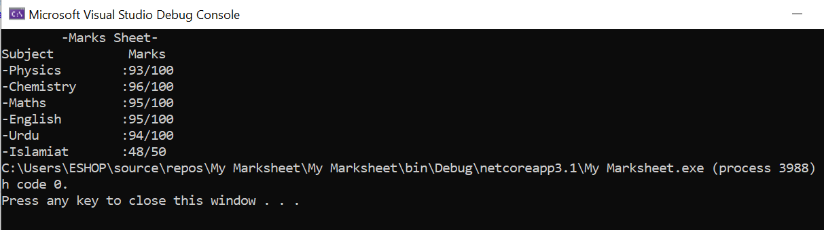
Task No 4: Write a C# program that displays the results of the expressions.
Input:
using System;

namespace Calculations_CP
{
class Program
{
static void Main(string[] args)
{

float a = 3.0F;
float b = 5.0F;
float ab = a * b;
Console.WriteLine("3.0 * 5.0 =" + ab);
float c = 7.1F;
float d = 8.3F;
float e = 2.2F;
float cde = c * d - e;
Console.WriteLine("7.1 * 8.3 - 2.2 = " + cde);
float f = 3.2F;
float g = 6.1F;
int h = 5;
float we = f / (g * h);
Console.WriteLine("3.2 / (6.1 * 5) = " + we);
int t = 15;
int o = 4;
int q = t / o;
Console.WriteLine("15 / 4 = " + q);
float p = 0.15F;
float l = p * o;
Console.WriteLine("!5% of 4 = " + l);
int j = 3;
int y = 6;
int r = h * j - (y * o);
Console.WriteLine("5 * 3 - (6 * 4) = " + r);

}
}
}

Output:
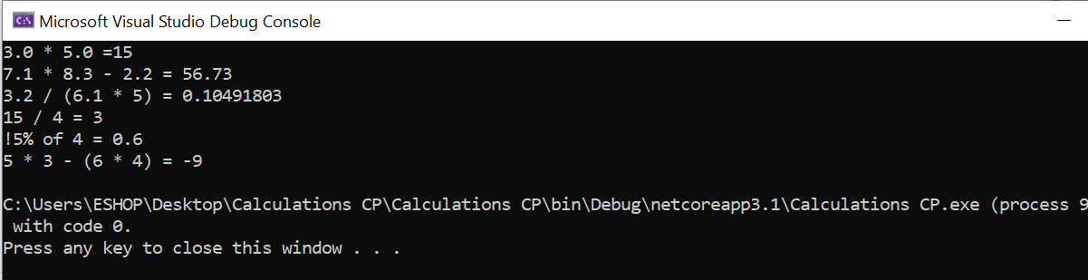

Task No 05: Calculate the temperature in Celsius using integer values.
Input:
using System;

namespace Abdullah_Sadiq_CP_Lab_3
{
class Program
{
static void Main(string[] args)
{
Console.WriteLine("Enter Temperature in Fahrenheit");
int f = Convert.ToInt32(Console.ReadLine());
int c = (f - 32)*5/9;
Console.WriteLine("The Temperature in Celcius is {0}", c);
}
}
}
Output:
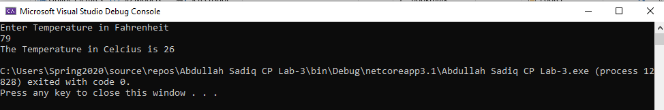
Task No 06: Calculate the area of Circle.
Input:
using System;

namespace Abdullah_Sadiq_CP_Lab_3
{
class Program
{
static void Main(string[] args)
{
int r = 8;
Console.WriteLine("Radius = 8cm");
Console.WriteLine("Pie = 22/7");
float a = r * r * 22 / 7;
Console.WriteLine("Area of Circle is {0}", a);
}
}
}
Output:
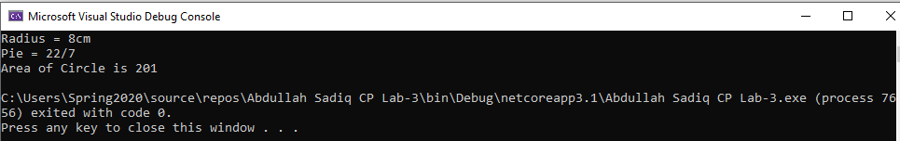
Task No 07: Display the result of the expression: ((( a + b) * (c * e * d)) – e)/f
Input:
using System;

namespace ConsoleApp1
{
class Program
{
static void Main(string[] args)
{
//(((a + b) * (c * e * d)) – e)/ f
int a, b, c, d, e, f;
a = 2; b = 3; c = 5; d = 4; e = 7; f = 1;

double result1 = (((a + b) * (c * e * d))-e);
double result2 = result1 / f;

Console.WriteLine("Given Expression\n(((a + b) * (c * e * d)) – e)/f\n\n Let\na = 2, b = 3, c = 5, d = 4, e = 7, f = 1,\n\nThe Result of the Expression Is {0}", result2);
}
}
}

Output:
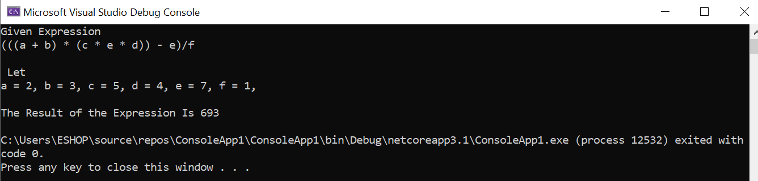

Task No 08: Write a program and print the output of first equation of the motion. For values take input from user. (vf=vi+at).
Input:
using System;

namespace Home_Task_07
{
class Program
{
static void Main(string[] args)
{
Double vf, vi, a, t;
Console.WriteLine("Enter initial Velocity: ");
vi = Convert.ToDouble(Console.ReadLine());
Console.WriteLine("Enter the acceleration: ");
a = Convert.ToDouble(Console.ReadLine());
Console.WriteLine("Enter time in seconds: ");
t = Convert.ToDouble(Console.ReadLine());

vf = vi + a * t;
Console.WriteLine("The final velocity of vehicle after {0} second is {1} m/s", t, vf);
}
}
}
Output:
